SAR Sardines, pilchards

*Sardinella lemuru* Diet of *S. lemuru* is typical of sardines, consisting predominantly of zooplankton. This study found that, for all but one of the sampling occasions, in waters off Geraldton the main planktonic group in the diet of *S. lemuru* was zooplankton and that unrecognisable detritus consistently made up at least 1/3 of the stomach contents. The presence of both zooplankton and phytoplankton in the diet of *S. lemuru* was not unexpected as most sardine species filter-feed, and thus have diets largely composed of plankton. The presence of unrecognisable detritus or “marine snow” as an important component in the diet

of *S. lemuru* has also been noted in other related species such as the Indian oil sardine *Sardinella longiceps* (Kumar and Balasubrahmanyan 1987). The importance of “marine snow”, with its organic content and associated bacteria, has been noted in the diet of many pelagic species.

Estimated average specimen volumes (L) of zooplankton organisms found in the diet of S. lemuru.

**Zooplankton type Average specimen volume** (L)

Eggs 2.5

Amphipoda 5.0

Cladocera 2.5

Calanoid copepods 5.0

Cyclopoid copepods 4.0

Harpaticoid copepods 2.0

Decapoda nauplii 2.5

Ostracoda 0.5

Bivalvia 0.5

Gastropoda 0.5

Tinntinnids 0.5

Salps 5.0

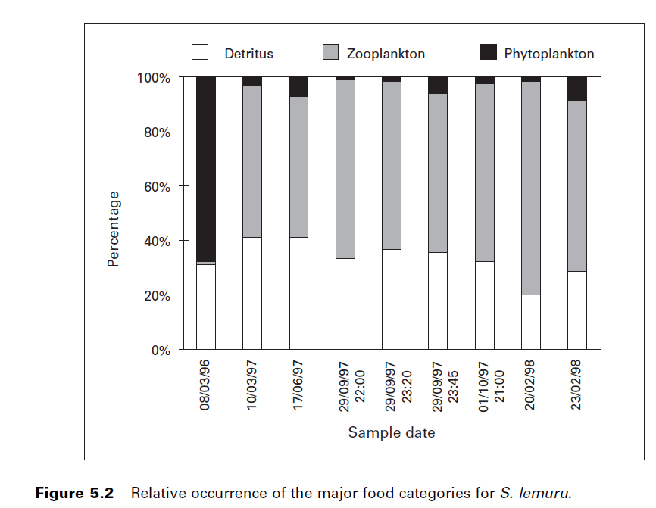

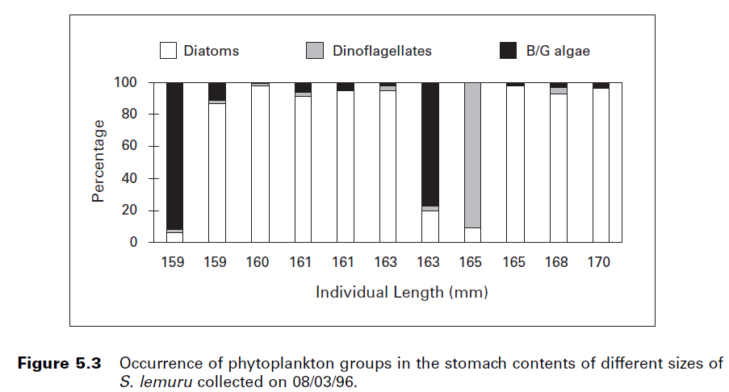

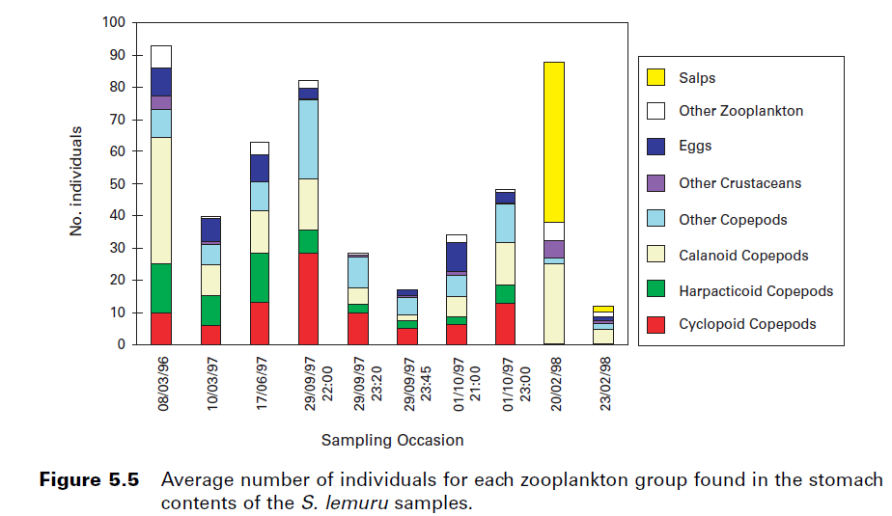

|  |  |
| --- | --- |
| **prey item** | **probability of consuming** |
| ZME | 0.3 |
| ZKL | 0.3 |
| SAL | 0.3 |
| PL | 0.2 |

Daniel J. Gaughan and Ronald W.D. Mitchell 2000. Final Report, FRDC Project 95/037:

The biology and stock assessment of the tropical sardine, Sardinella lemuru, off the

mid-west coast of Western Australia. Fisheries Research Report no. 119, 2000.